Day – 5
Operating system information, windows, Linux, macOS installation and adjust OS settings.
1.On your Windows laptop or PC, open 'System Information' and take a screenshot showing your OS version, processor, and RAM details.
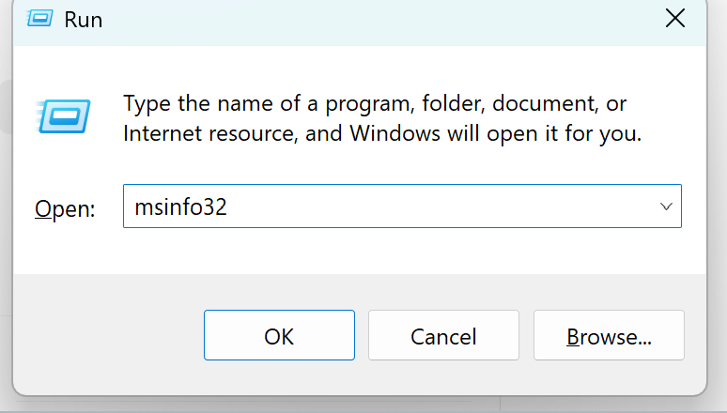
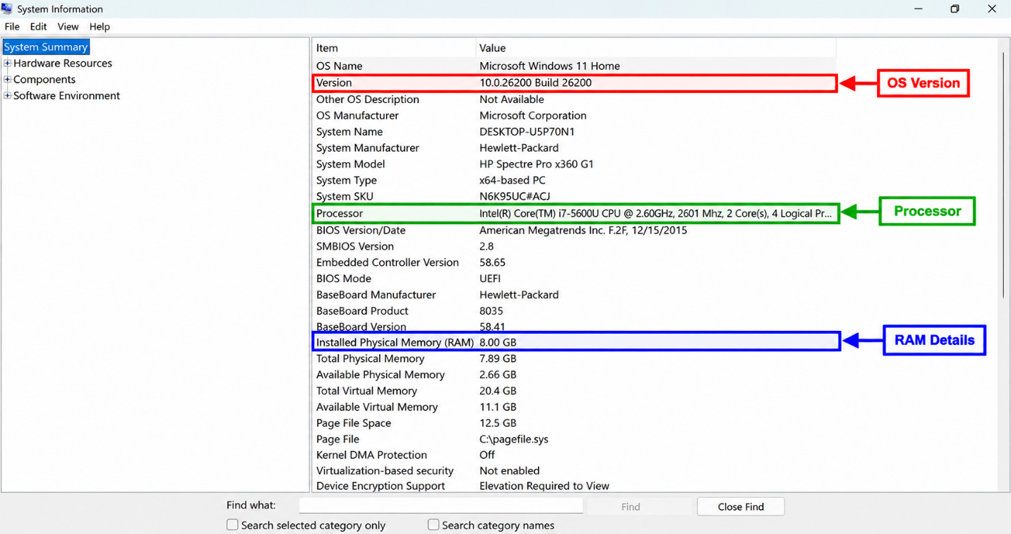

2.Download any official Linux distribution ISO (like Ubuntu or Fedora), and use Rufus or BalenaEtcher to create a bootable USB drive for installation.
Step 1 — Download Ubuntu ISO
Go to the official Ubuntu download page and download Ubuntu Desktop ISO.
What you do:
- Open the official Ubuntu website.
- Select Ubuntu Desktop.
- Click Download.
- Save the .iso file on your computer.
The current Ubuntu release page provides the 64-bit Desktop ISO for PCs.
Step 2 — Insert the USB drive
Insert an 8 GB or larger USB flash drive into the computer.
⚠️ Important: Creating the bootable USB will erase the existing data on the USB, so back up any important files first. Ubuntu also explicitly warns that creating installation media erases the USB. Ubuntu
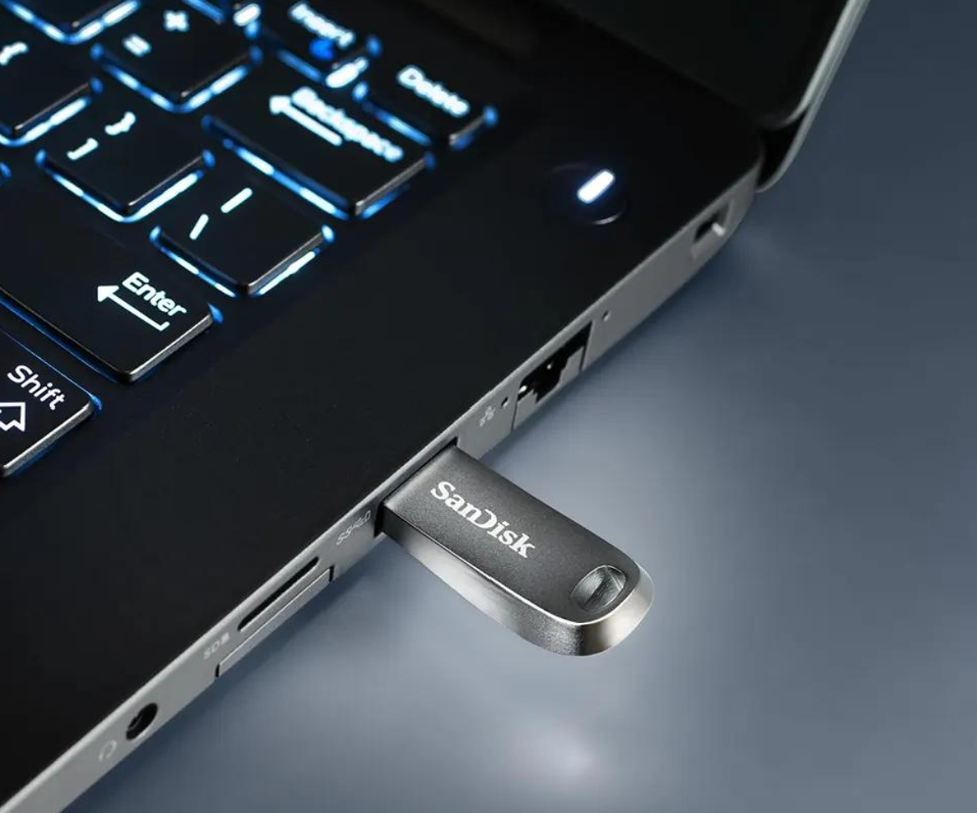

Step 3 — Open Rufus
Download and open Rufus.
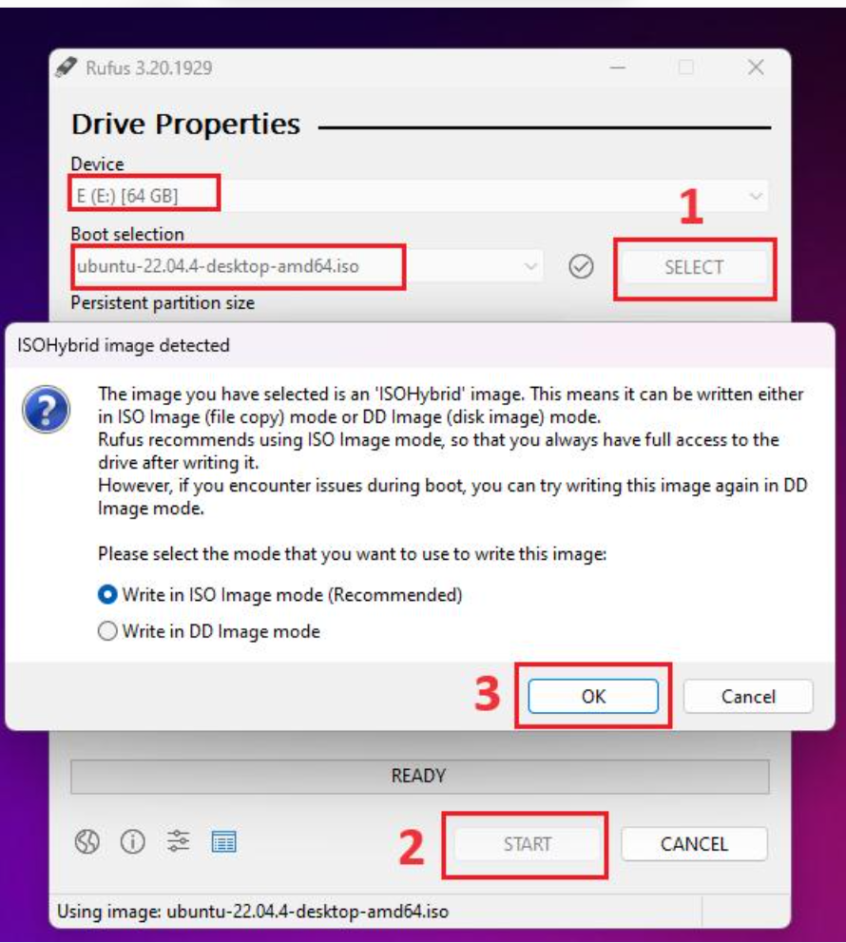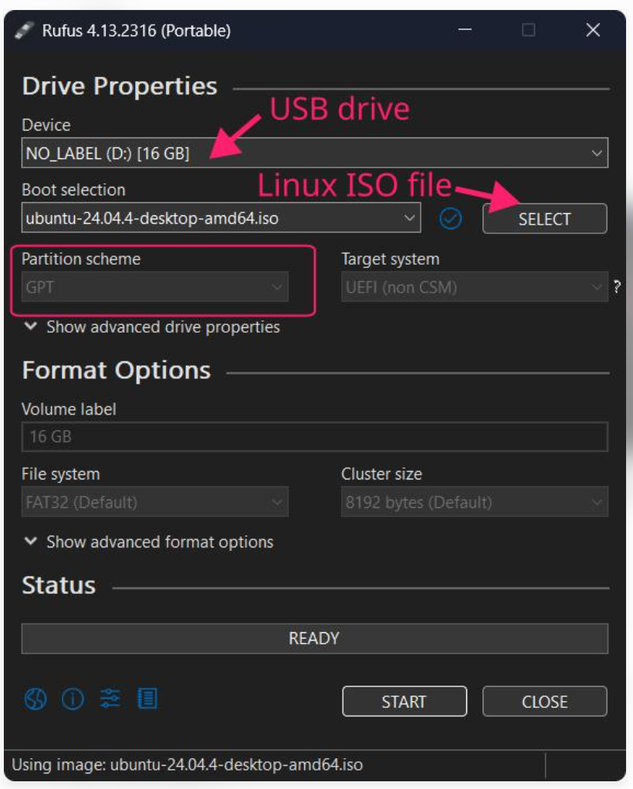
The actual Rufus interface contains fields such as Device, Boot selection, Partition scheme, Target system, and File system.
Step 4 — Select Ubuntu ISO
In Rufus:
- Check that your correct USB appears under Device.
- Click SELECT.
- Locate the downloaded Ubuntu .iso file.
- Select it.
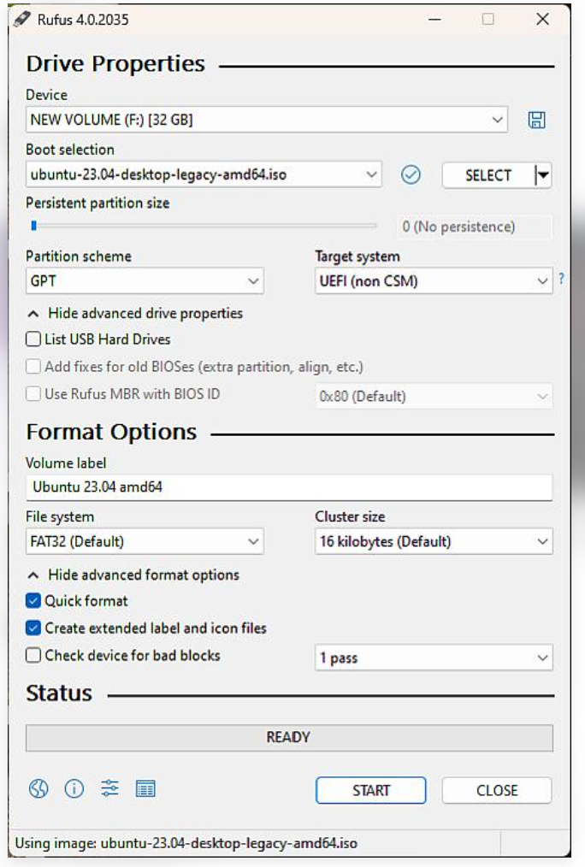

Step 5 — Configure Rufus
After selecting the ISO, Rufus displays the Ubuntu image and USB information.
A typical modern UEFI computer will use:
- Boot selection: Ubuntu ISO
- Partition scheme: GPT
- Target system: UEFI
- File system: FAT32, when offered

Step 6 — Confirm the ISO writing process
Rufus may display a confirmation asking how to write the image.
Select the recommended ISO Image mode, if prompted, and continue.
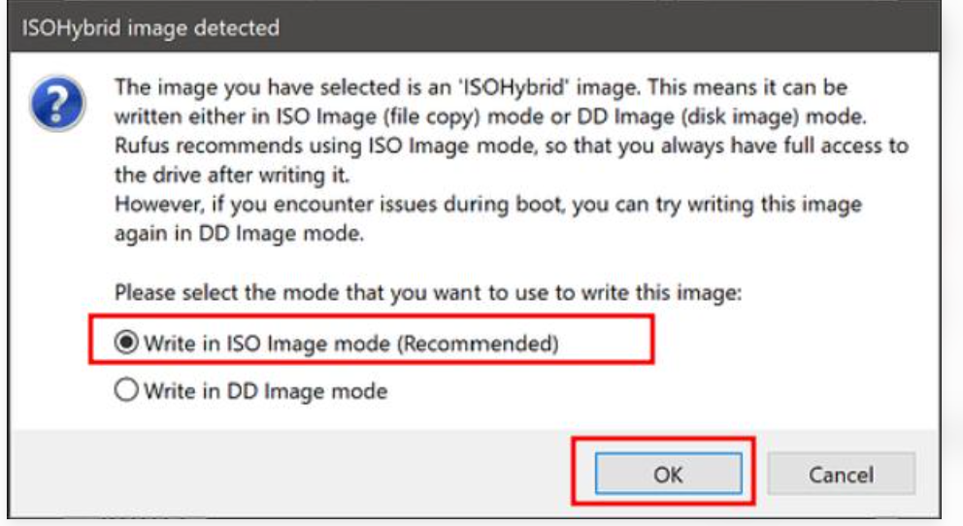
Step 7 — Wait for Rufus to finish
Rufus formats the USB and copies the required Ubuntu boot files.
Step 8 — Boot the computer from USB
Restart the computer while the USB is connected.
During startup, open the Boot Menu. Common keys include:
- F12
- F9
- Esc
- F10
- F2
The exact key depends on the computer manufacturer. Ubuntu notes that F12 is commonly used, with Esc, F2 and F10 also used on some systems.
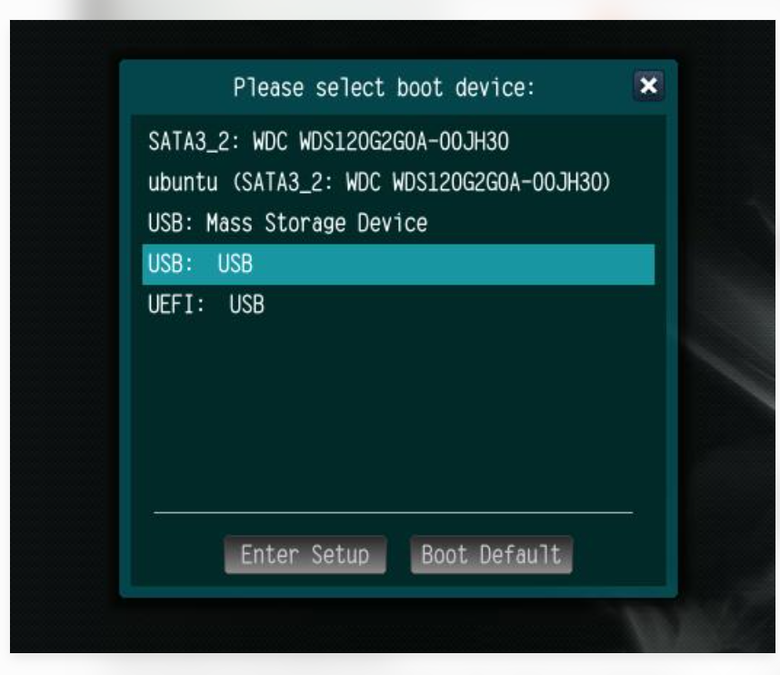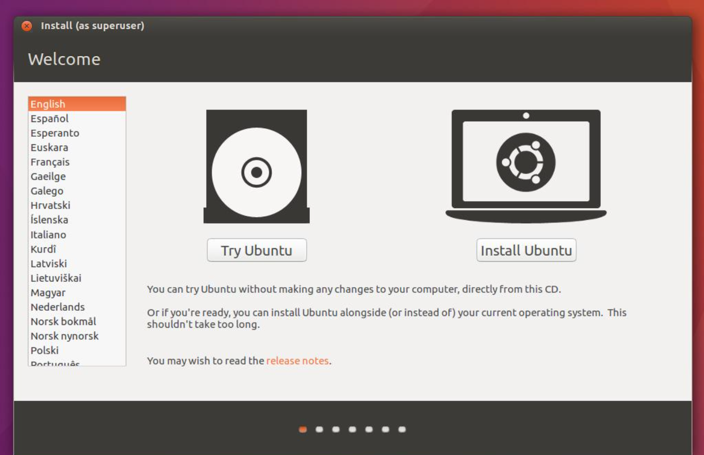
Result: Ubuntu Desktop ISO was successfully written to a USB flash drive using Rufus. The USB became bootable and was successfully recognized as a boot device. It can now be used to try or install Ubuntu Linux.
3.On a macOS device (or using a macOS virtual machine), open 'System Preferences' and change the desktop wallpaper, then adjust the system language to Hindi or Gujarati.
Part A — Change the Desktop Wallpaper
Step 1: Open the Apple Menu
- Start the Mac/macOS virtual machine.
- Click the Apple () menu in the top-left corner.
- Select System Preferences.
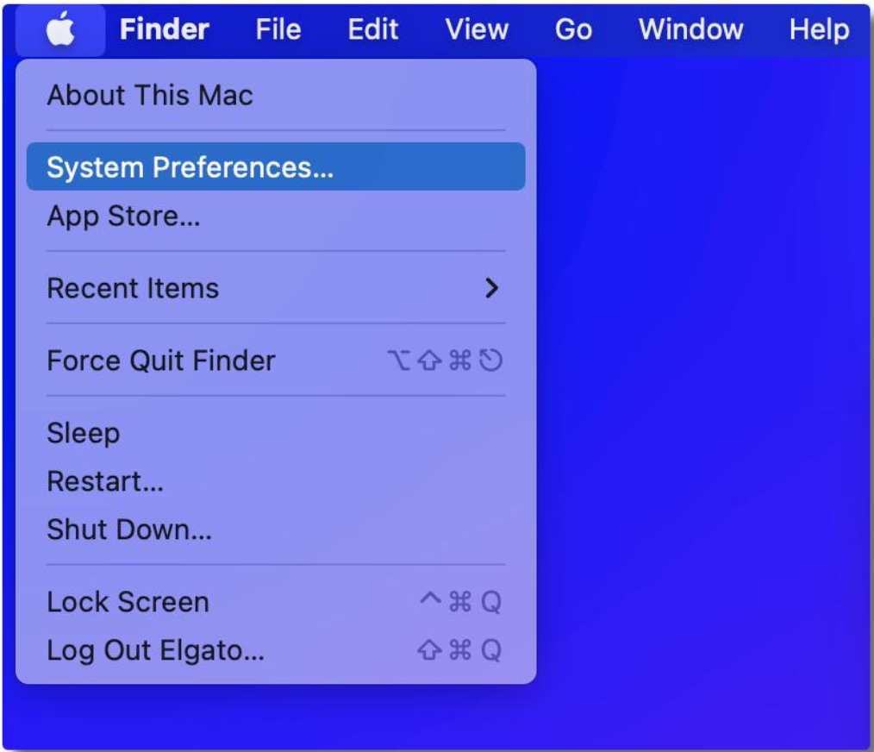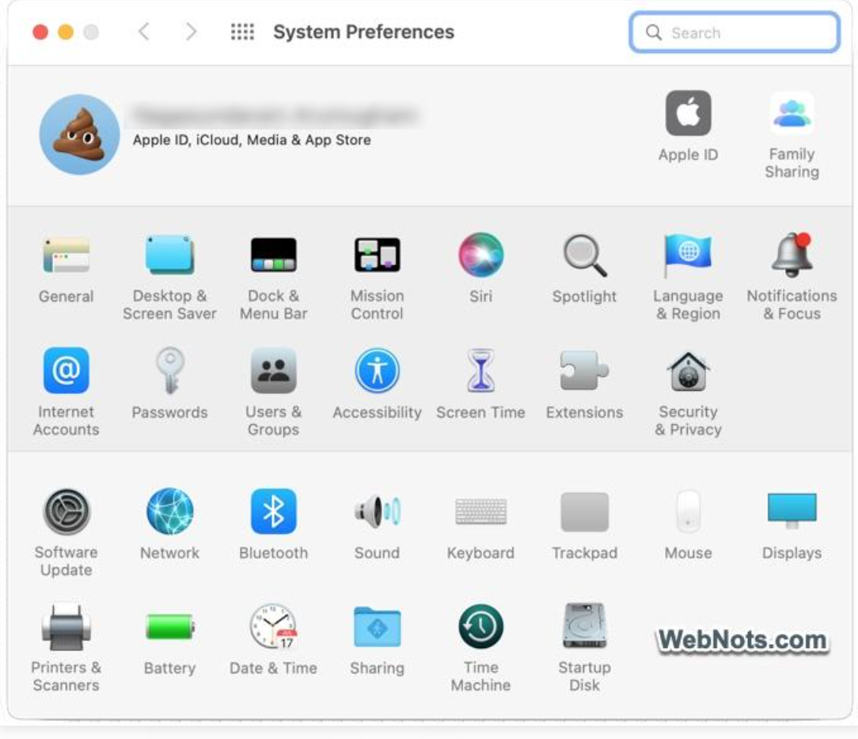
Step 2: Open Desktop & Screen Saver
Inside System Preferences, find and click:
Desktop & Screen Saver
This is the macOS setting used to customize the desktop background.
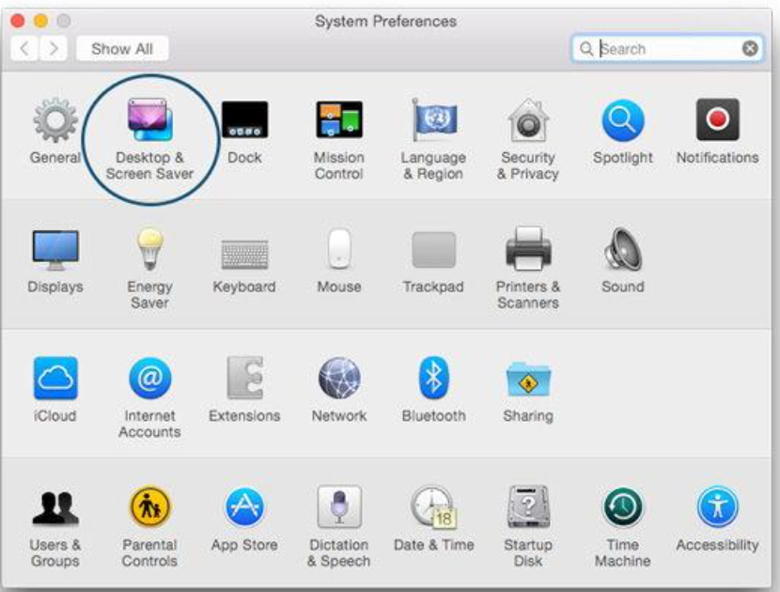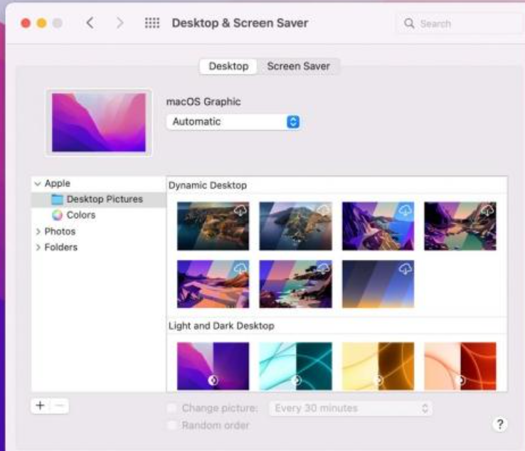
Step 3: I selected the Desktop tab and chose a wallpaper from the available Desktop Pictures. The selected image was automatically applied as the desktop background.
step 4: Use Your Own Image — Optional
If you want to use a personal image:
- Select Folders on the left.
- Click the + button.
- Select the folder containing the image.
- Select the image.
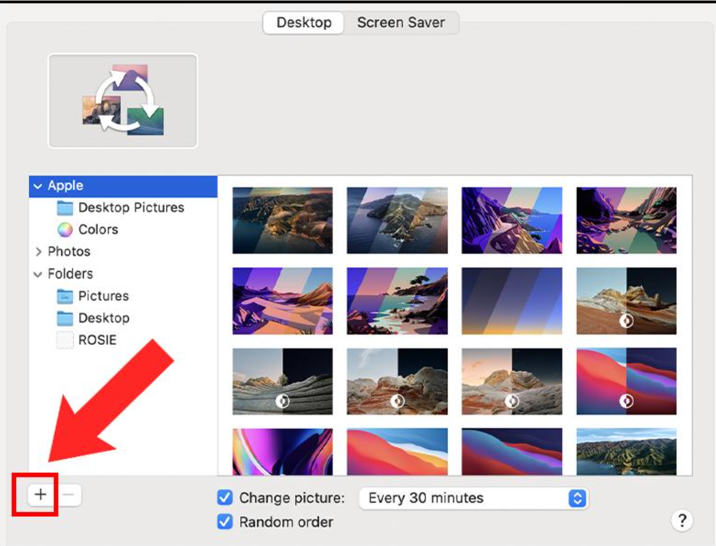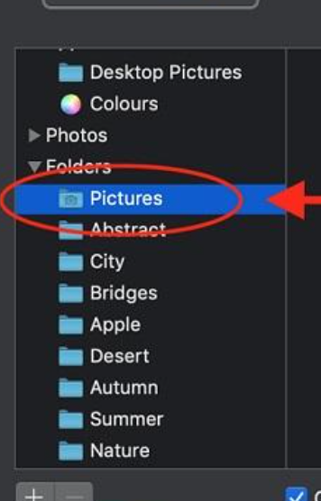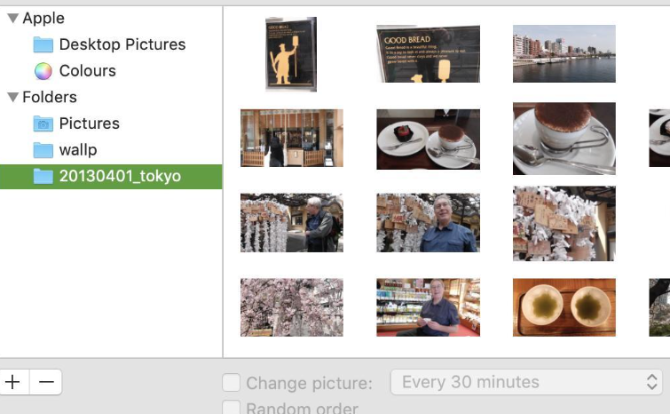

✅ Wallpaper Result
After selecting the image, the macOS desktop should display the new wallpaper.
Assignment result:
Result: The desktop wallpaper was successfully changed using System Preferences → Desktop & Screen Saver.
Part B — Change System Language to Hindi/Gujarati
Now we change the language.
Step 5: Open Language & Region
Go back to:
Apple Menu  → System Preferences
Then click:
Language & Region
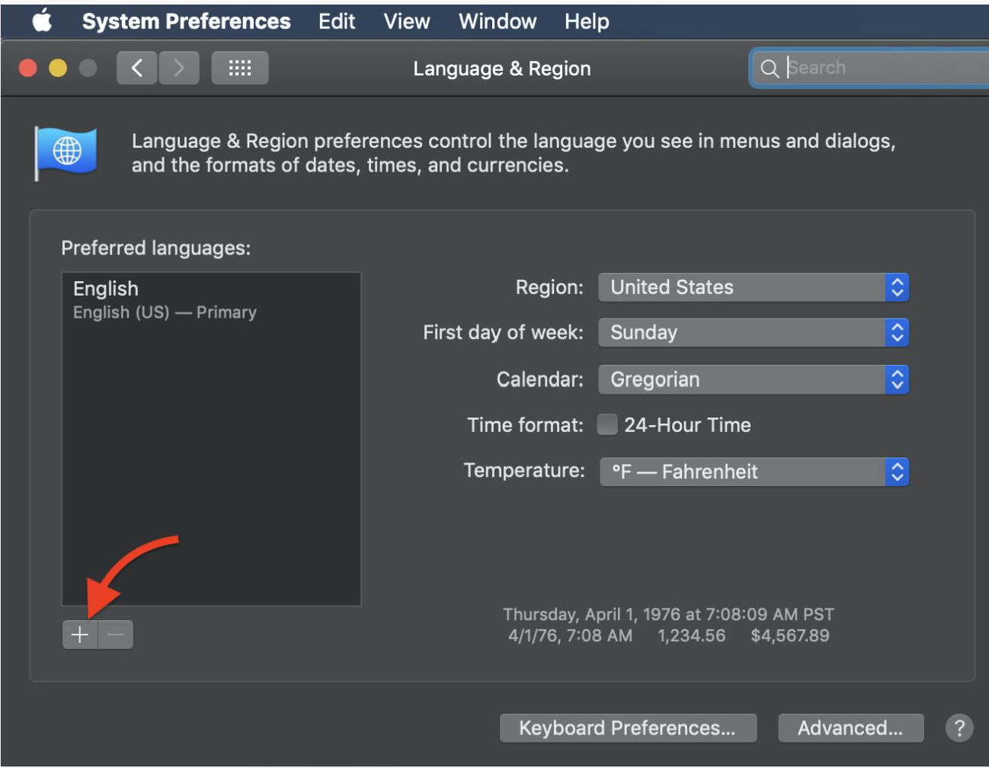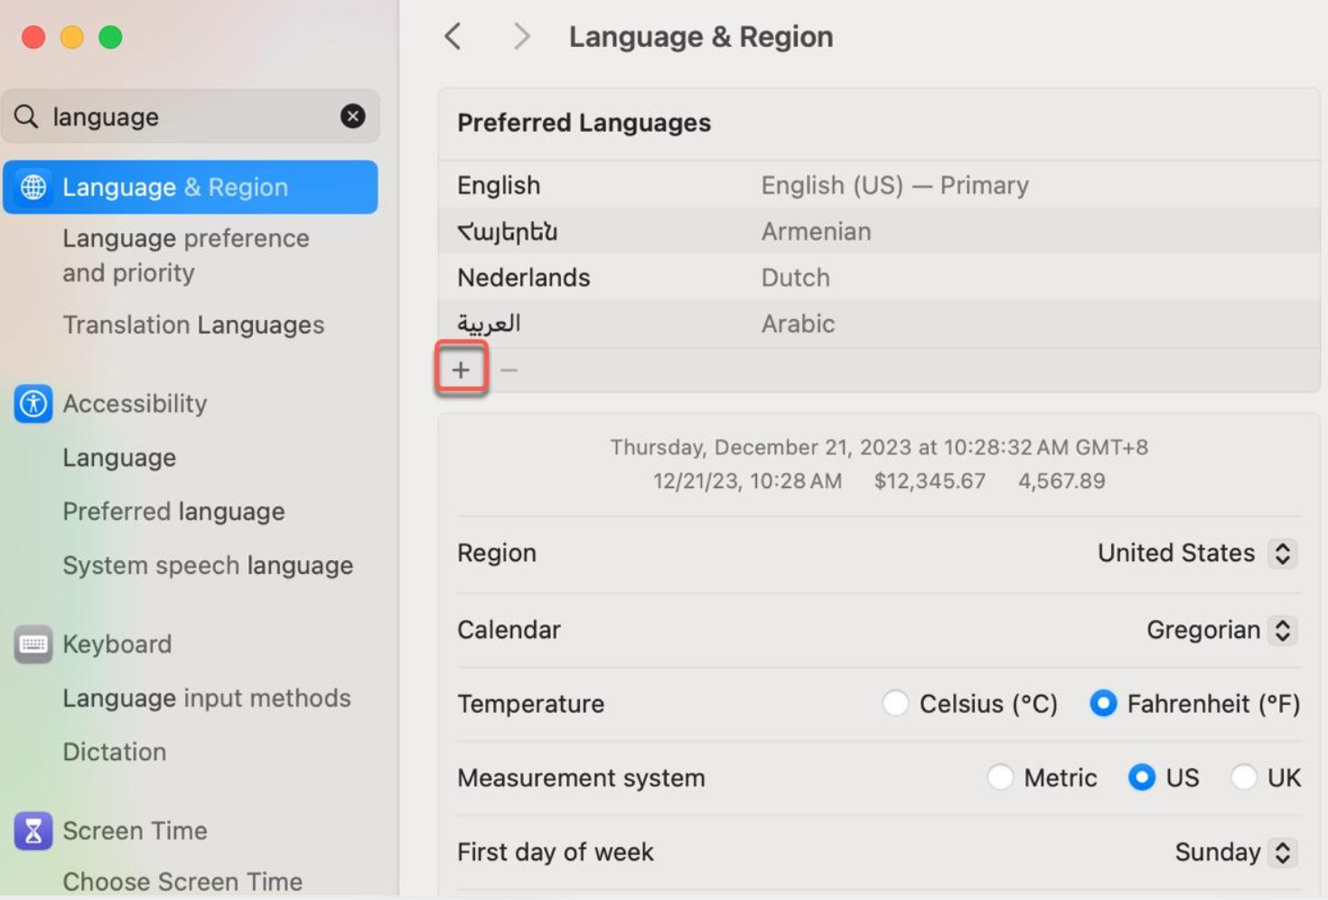
Step 7: Select Hindi or Gujarati
A list of languages will appear.
Search for either:
Hindi
or
Gujarati
For your assignment, you can choose Gujarati.
Select Gujarati and click Add.

Step 8: Restart/Log Out if Required
macOS may ask you to log out or restart for the language change to take effect.
If prompted:
- Save your work.
- Log out or restart the Mac.
- Sign in again.
The macOS interface should now use the selected language where supported.
Write in your assignment:
Step 9: I logged out and signed in again when prompted so that the language changes could take effect.

✅ Final Result
Result: The desktop wallpaper was successfully changed using System Preferences → Desktop & Screen Saver, and Gujarati was added and selected as the preferred system language through System Preferences → Language & Region.
4.Install a fresh copy of Ubuntu Linux (real or virtual machine) and create a new user account named 'gamer'. After installation, enable automatic login for this user and take a screenshot of the login screen showing the username.

Part A — Create an Ubuntu Virtual Machine
Step 1: Open VirtualBox
- Open Oracle VirtualBox.
- Click New.
- Enter:
Name: Ubuntu Gamer
- Select the Ubuntu ISO file you downloaded earlier.
- Select Linux → Ubuntu (64-bit) if VirtualBox asks for the operating system.
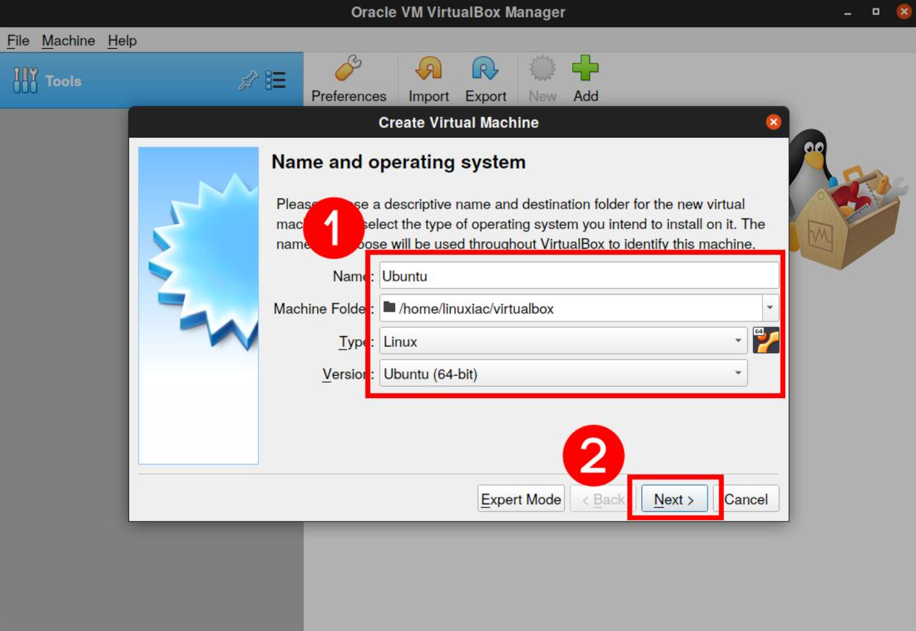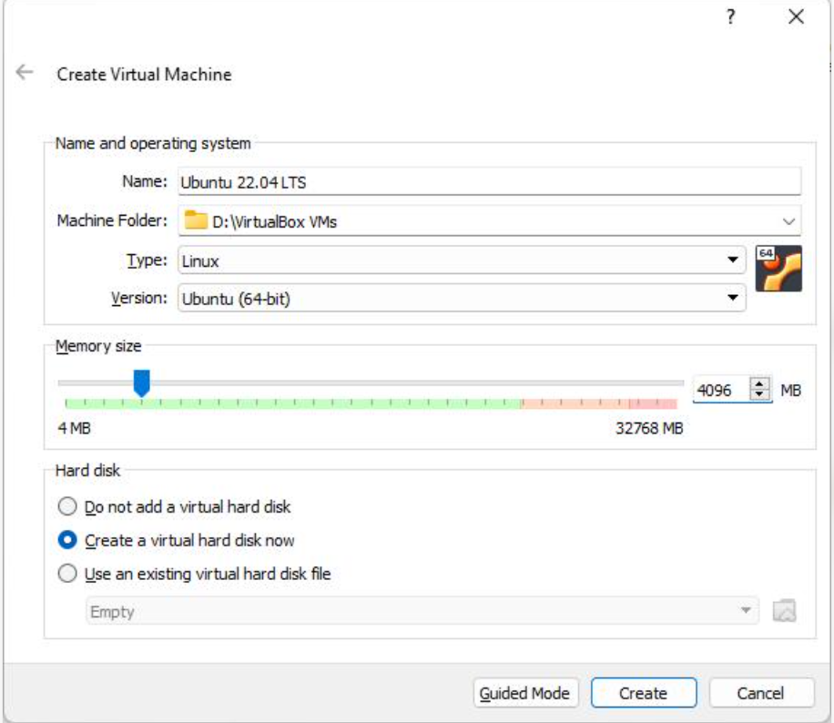
Part B — Install Ubuntu
Step 2: Start the Virtual Machine
Click Start.
Ubuntu will boot from the ISO and display the Ubuntu installation screen.
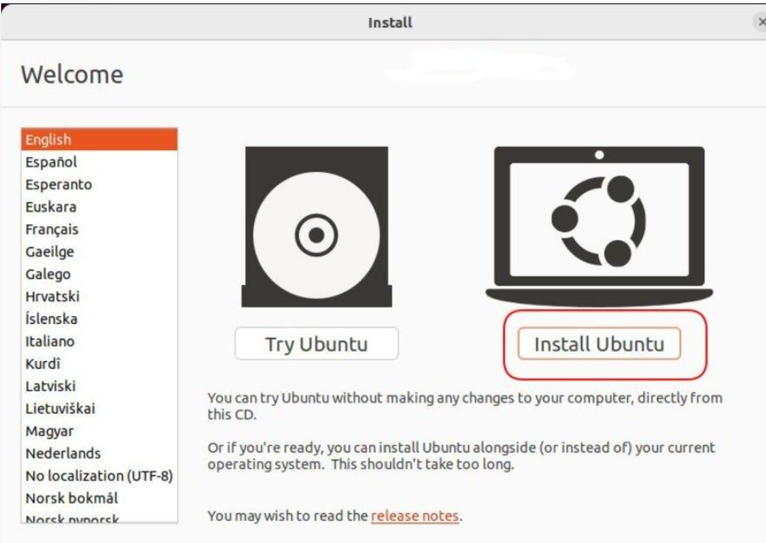
Step 3: Select Language and Keyboard
Choose your preferred language, such as:
English
Then select the appropriate keyboard layout.
Click Continue.
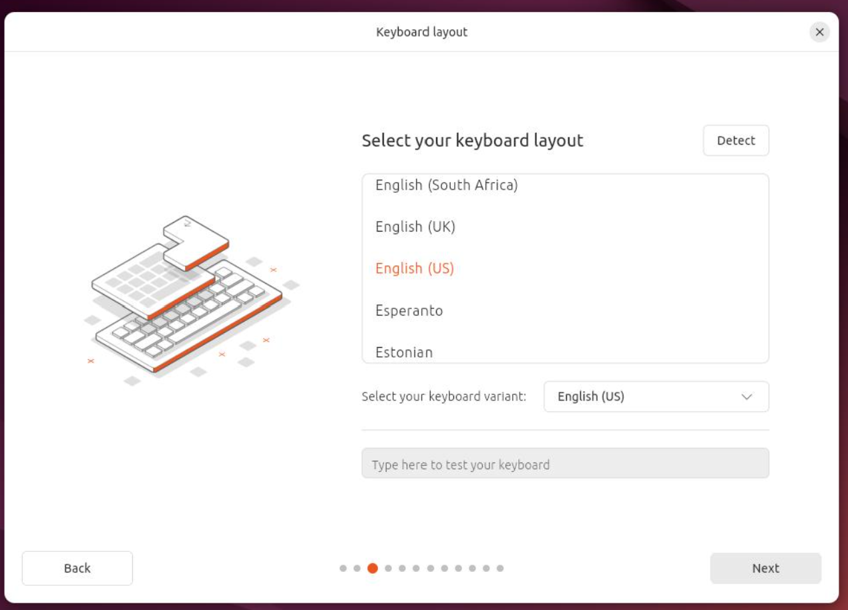

Step 4: Configure Installation
Continue through the Ubuntu installation wizard.
For a virtual machine, you can select the default installation options.
When asked about disk usage, select the option to use the virtual disk.
Important: This affects the virtual disk created for VirtualBox, not your normal Windows disk directly.
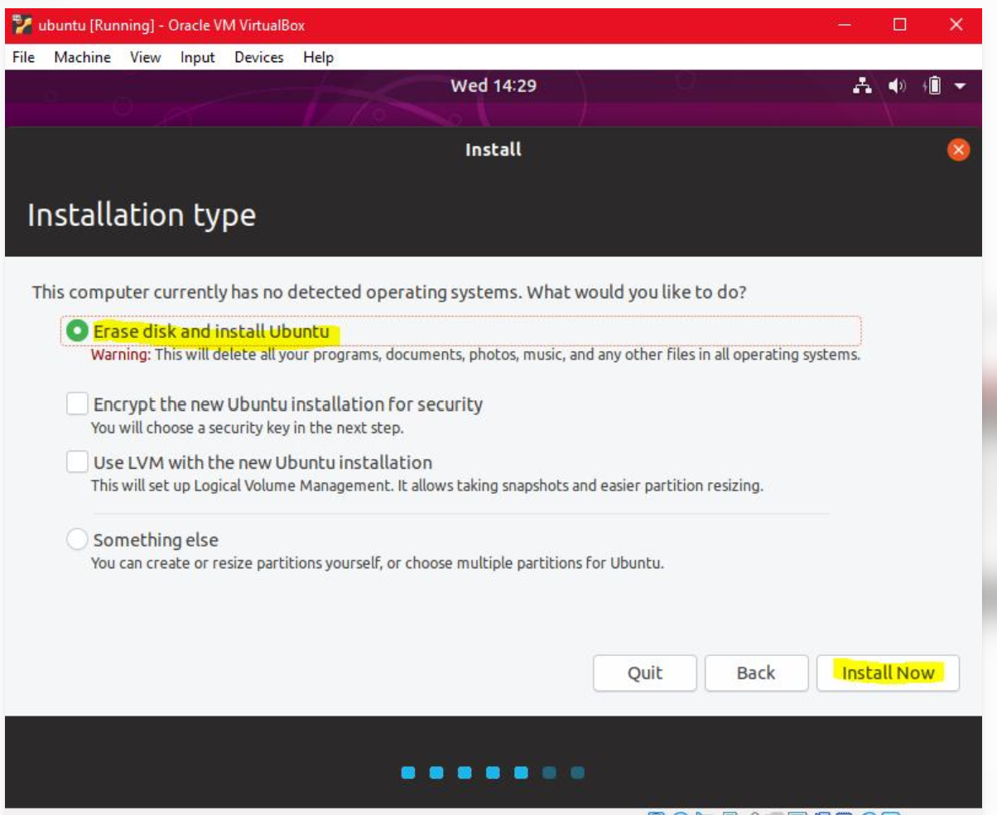
Part C — Create the gamer Account
Step 5: Create Your User Account
During Ubuntu installation, you will reach the Create your account screen.
Enter something similar to:
Field | Value
Your name | Gamer
Computer name | ubuntu-gamer
Username | gamer
Password | Choose a password
Confirm password | Same password
The important field for this assignment is:
Username: gamer
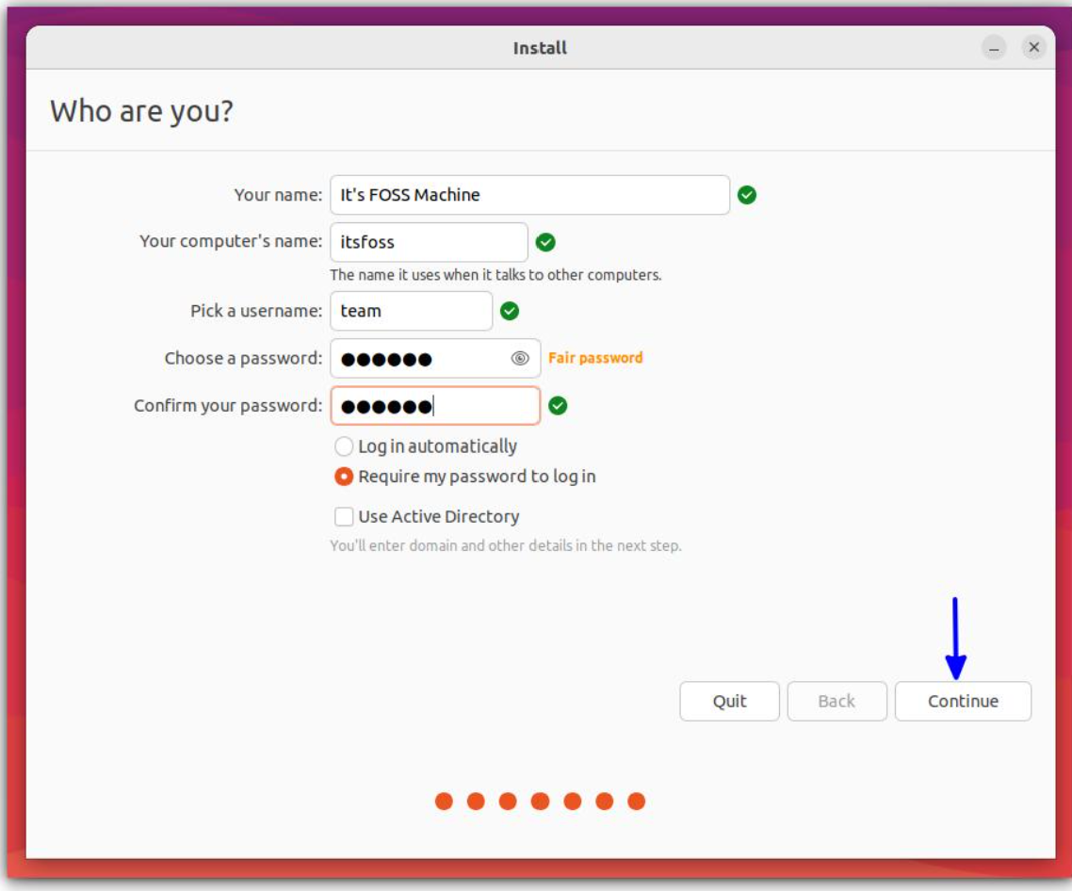
Step 6: Complete Installation
Click Continue and allow Ubuntu to install.
The installer will copy the required files to the virtual disk.
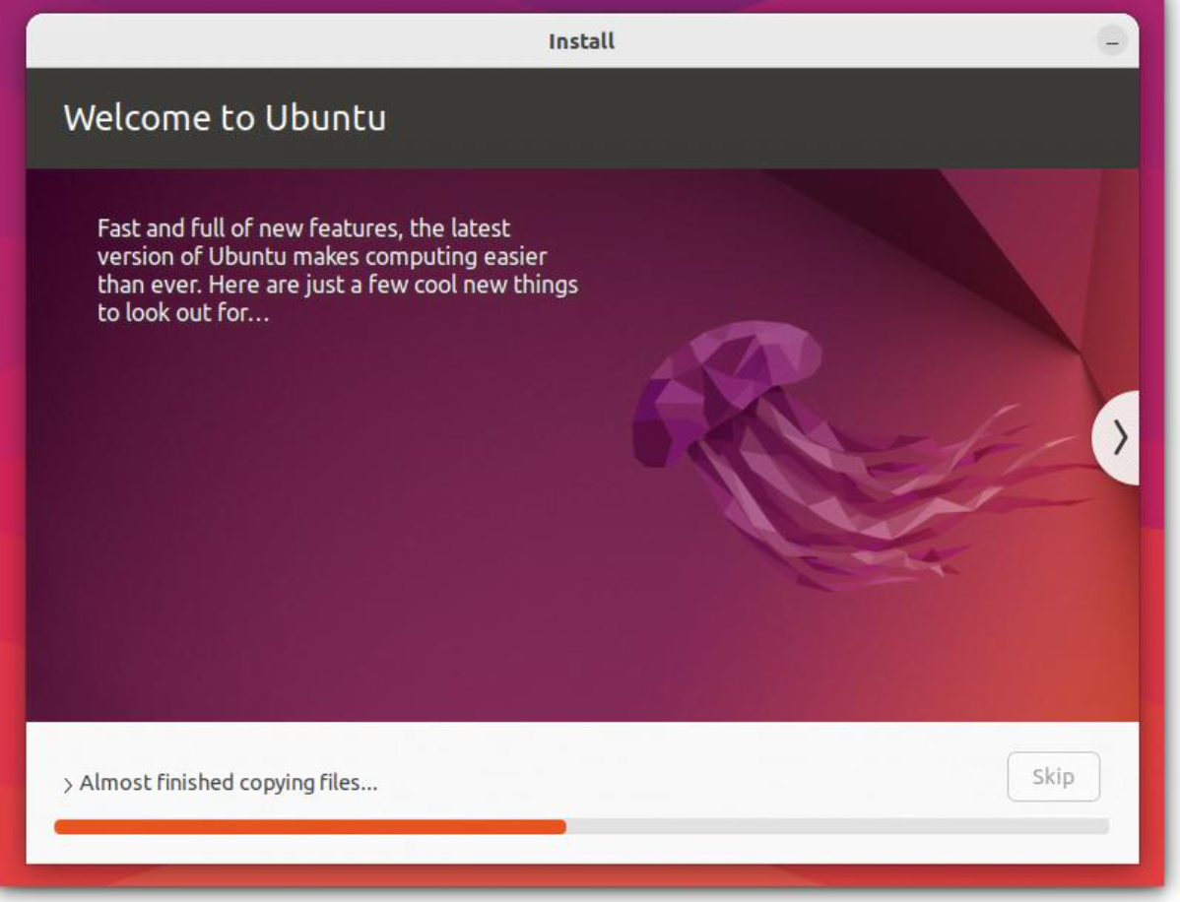
Part D — Enable Automatic Login
Now Ubuntu is installed and the gamer account exists.
Step 7: Open Settings
After logging into Ubuntu:
- Click the system menu in the top-right corner.
- Click Settings.
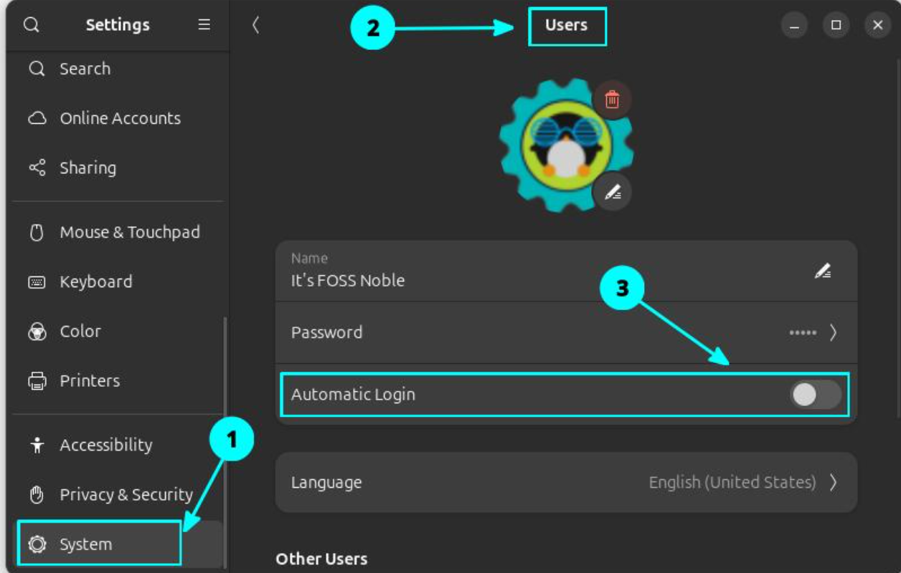
Step 8: Open Users
In Settings:
System → Users
Depending on the Ubuntu version, you may simply see Users in the Settings sidebar.
You may need to click Unlock and enter your password before changing account settings.
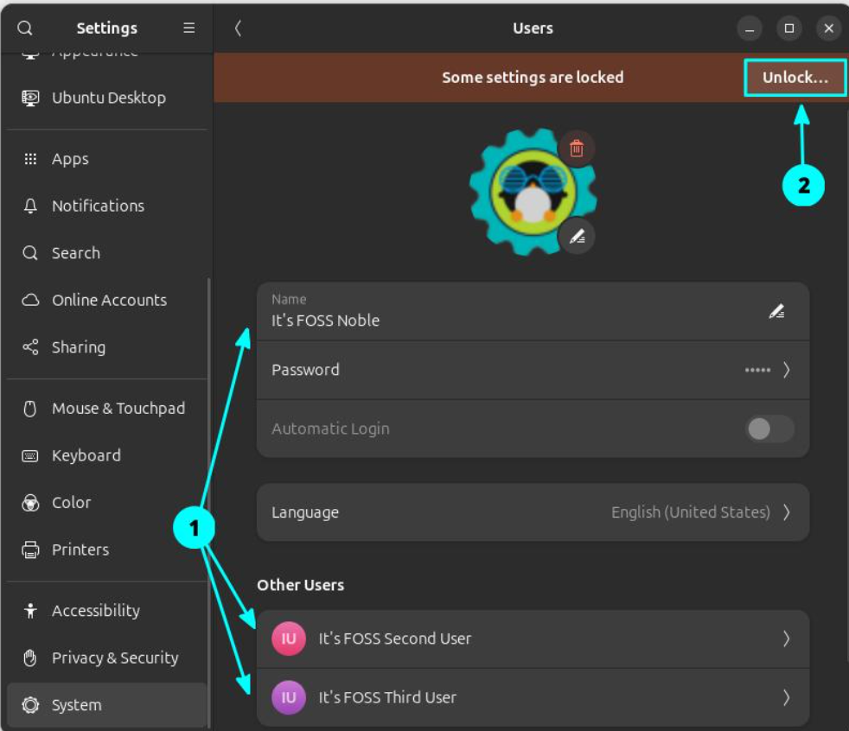

Step 9: Enable Automatic Login
Select the gamer account.
Look for:
Automatic Login
Turn the switch ON.
The setting should show that automatic login is enabled for the gamer account.
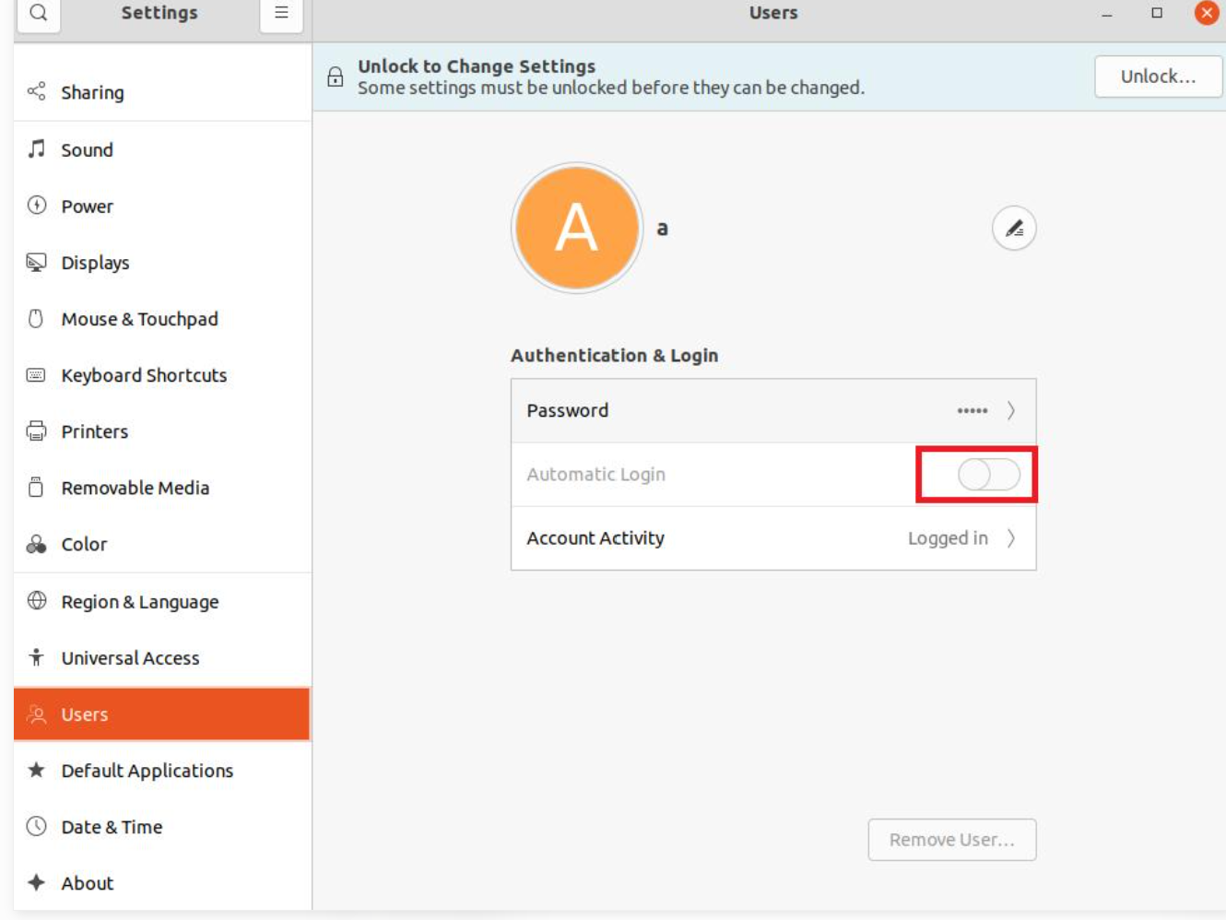
Part E — Verify Automatic Login
Step 10: Restart Ubuntu
Restart the virtual machine:
System Menu → Power → Restart
Because automatic login is enabled, Ubuntu should automatically log in to the gamer account instead of asking for the password.
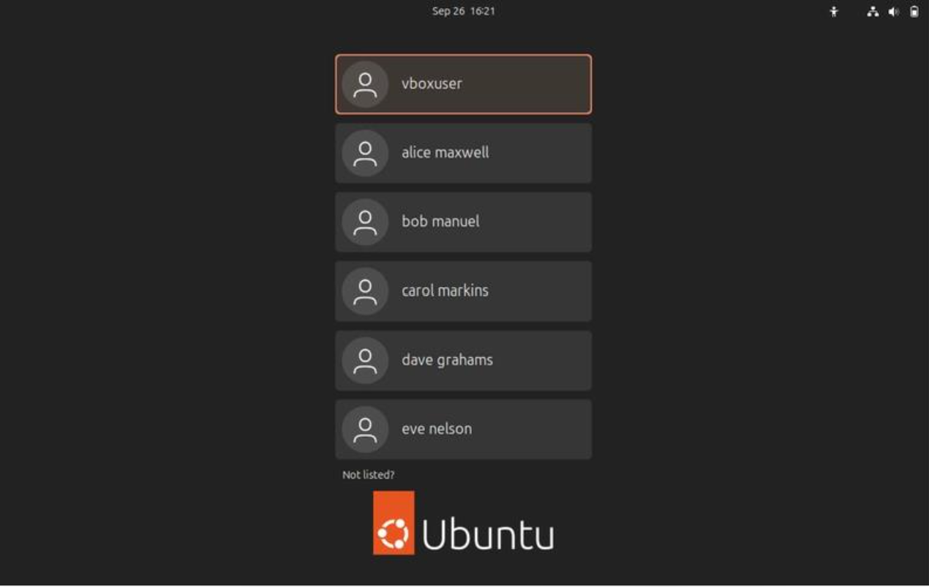
Procedure: I installed Ubuntu Linux in Oracle VirtualBox using the Ubuntu ISO image. During installation, I created a new user account with the username gamer. After completing the installation, I opened Settings → Users, selected the gamer account, and enabled Automatic Login. I then restarted/logged out of Ubuntu and verified the account by checking the login screen, where the gamer username was displayed.
Result: Ubuntu Linux was successfully installed, the gamer user account was created, and automatic login was enabled successfully.

5.Use ChatGPT to generate a step-by-step guide for installing Windows 10 on a laptop, including partitioning tips and post-installation settings for privacy and updates. Follow the guide and note any steps that were unclear or missing.
Part A — Requirements
Before starting the installation, prepare:
- Windows 10 ISO file
- Bootable USB drive (8 GB or larger)
- Laptop/PC
- Backup of important files
- Internet connection
- Windows product key, if required
Important: A clean installation can erase existing files and partitions. Back up important data before proceeding.
Part B — Windows 10 Installation
Step 1: Create a Windows 10 Bootable USB
- Download the Windows 10 ISO from Microsoft's official website.
- Use a tool such as Rufus to write the ISO to a USB drive.
- Select the USB as the target device.
- Select the Windows 10 ISO.
- Start the process and wait until the bootable USB is created.
Assignment observation:
ChatGPT's guide clearly explained that a bootable USB is required, but it did not initially specify the exact Rufus settings for every type of computer. The appropriate settings can depend on whether the laptop uses UEFI/GPT or Legacy BIOS/MBR.
Step 2: Boot the Laptop from USB
- Insert the Windows 10 USB.
- Restart the laptop.
- Open the Boot Menu during startup.
- Common boot-menu keys include F12, F9, Esc, or F2, depending on the manufacturer.
- Select the USB drive.
The Windows Setup screen should appear.

Step 3: Select Installation Preferences
Windows Setup asks for:
- Language to install
- Time and currency format
- Keyboard/input method
Select the appropriate options and click Next.
Then click:
Install now

Step 4: Enter the Product Key
Windows may ask for a product key.
You can:
- Enter your valid Windows product key, or
- Select I don't have a product key if you intend to activate Windows later and your license permits it.
Choose the appropriate Windows 10 edition if prompted.

Part C — Partitioning
Step 5: Choose Installation Type
When Windows asks:
Which type of installation do you want?
Choose:
Custom: Install Windows only (advanced)
You will see the available disk partitions.

Step 6: Partitioning Tips
This is one of the most important parts of the installation.
If performing a clean installation:
- Do not delete partitions containing important personal files.
- If the laptop already contains Windows and you want to completely replace it, identify the existing Windows/system partitions carefully.
- You can create a new partition for Windows by selecting Unallocated Space → New.
- Windows will automatically create several required system/recovery partitions.
- Select the appropriate primary partition and click Next.
Recommended approach for a normal assignment
If the entire disk is being used for Windows and there is no important data, using the available unallocated space and allowing Windows Setup to create the required partitions is safer than manually creating every system partition.
Assignment observation:
The partitioning step was potentially unclear because deleting or formatting the wrong partition can result in permanent data loss. Therefore, the disk size and partition names should be checked carefully before making any changes.

Part D — Windows Installation
Step 7: Wait for Installation
Windows Setup will:
- Copy Windows files.
- Install the required features.
- Install updates that are available during setup.
- Restart the computer several times.
Do not remove the installation USB until Windows has progressed to the appropriate setup stage.

Part E — Initial Windows Setup
Step 8: Configure Region and Keyboard
After installation:
- Select your region.
- Select the keyboard layout.
- Add another keyboard layout if required.

Step 9: Connect to the Internet
Connect to Wi-Fi or Ethernet if available.
An internet connection allows Windows to download updates and complete setup.

Step 10: Create/Sign In to an Account
Follow the Windows setup instructions to sign in with or create the appropriate user account.
Create a strong password/PIN.

Part F — Privacy Settings
Step 11: Review Privacy Options
During Windows setup, review the available privacy settings rather than simply accepting every default.
After installation, go to:
Settings → Privacy
Review settings related to:
- Location
- Camera
- Microphone
- Account information
- Contacts
- Calendar
- Diagnostics
- App permissions
Only enable permissions that applications actually need.
Assignment text:
I reviewed the Windows privacy settings and disabled unnecessary permissions, particularly access to location, camera, microphone, and other personal information where they were not required.
Part G — Windows Updates
Step 12: Check Windows Update
Open:
Settings → Update & Security → Windows Update
Click:
Check for updates
Install the available updates and restart the computer if required.
Part H — Post-Installation Checks
After installation, check:
1. Windows Activation
Go to:
Settings → Update & Security → Activation
Check whether Windows is activated.
2. Device Manager
Right-click Start → Device Manager.
Check whether any hardware has a yellow warning symbol.
3. Storage
Open:
Settings → System → Storage
Check available disk space.
4. Windows Security
Open:
Settings → Update & Security → Windows Security

